**Product Requirements Rev *n.n***

**Summary:** This document outlines the requirements for the Aigen ground vehicle platform. The aerial platform requirements are detailed in a separate document.

1. **Product Name**
   1. Ground Robotics Platform
2. **Product Function**
   1. Provide herbicide free weed control
   2. Generate reports
   3. House and protect aerial robot
   4. Launch aerial robot
3. **Who is it for?**
   1. Agriculture professionals, farmers, and technicians at large enterprise farms
4. **Speed**
   1. 4 acres covered per day with no scouting (~1.5 mph).
   2. 12 acres per day with scouting
   3. Min 1.5 mph
5. **Dimensions**
   1. Must fit in box with less than 165 inches in combined length and girth (UPS limit)
   2. Can turn within 5 feet of crop end rows
   3. Adjustable width from 20” to 30”. Clears 10” furrows and 14” sugarbeets. (Note the sugarbeets do conform out of the way of the robot)

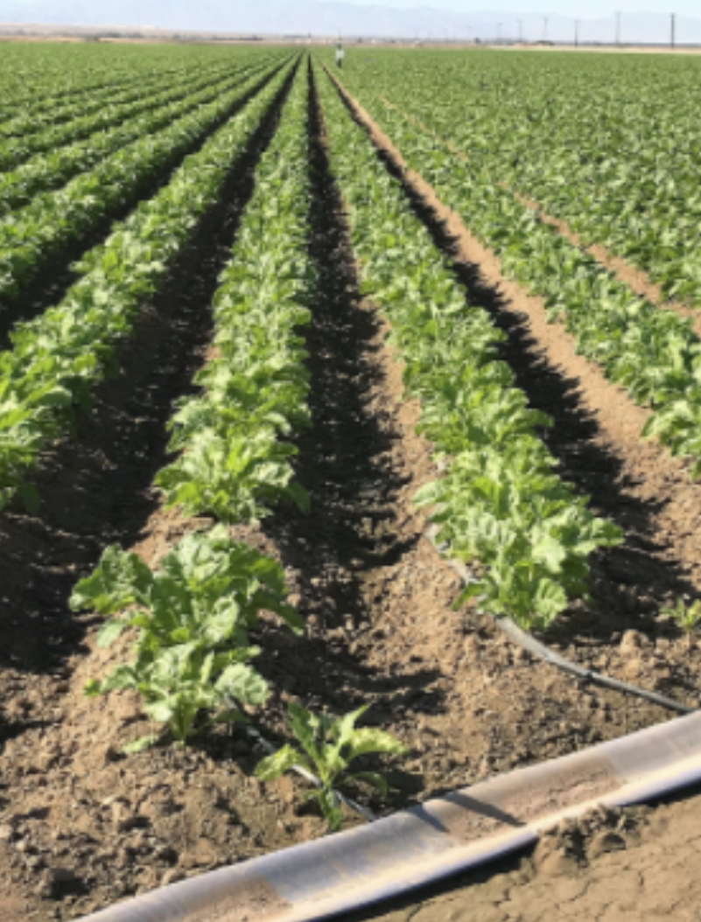

**Figure 1:** Sugarbeets Example

1. **Weight**
   1. Max 110 lbs without packaging
   2. based on 150 lbs UPS shipping limit
2. **Power Source**
   1. Solar for daytime operation
   2. Battery packs for nighttime operation and when solar energy doesn’t provide enough power for operation
3. **User Interface**
   1. Cell phone application
   2. Ability to outline area
   3. Ability to see location of all robots
   4. Ability to control robots manually from location
   5. Ability to schedule inspections or actions at the farm
   6. Reports generated on ground robot show crop analytics and recommendations

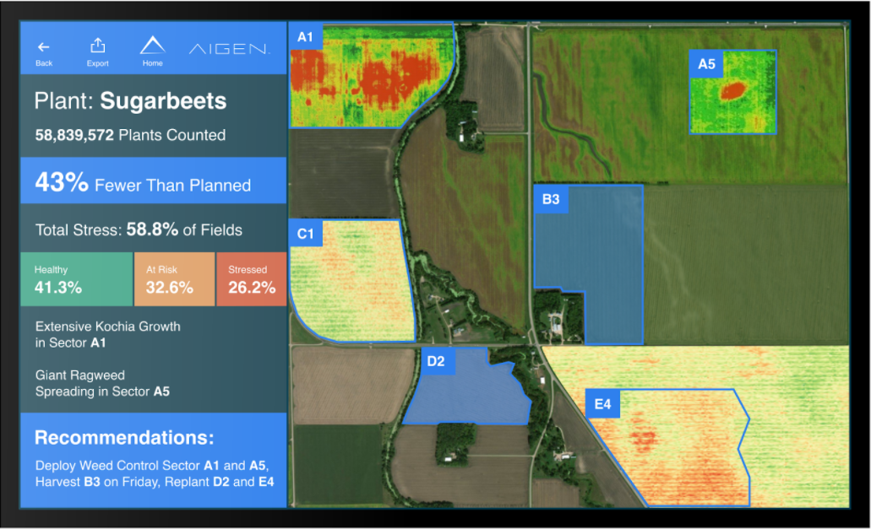

**Figure 2:** Example Survey Screen

1. **Weed Control Mechanism:** 
   1. Kill 5,000 weeds per acre and 4 acres a day, 0.23 weeds per second. Or one every 4 seconds.
   2. Herbicide free
2. **Control**
   1. Autonomous with customer manual override
3. **Communications**
   1. Close range high data transfer rate to WiFi networks at farms
   2. Mesh communications between robots
   3. Cellular networking ability for farm connectivity
   4. GPS for location tracking
4. **Price**
   1. Maximum cost to manufacture: $2,500
5. **Environmental Conditions**
   1. Needs to climb slopes up to 35 degrees
   2. Must operate in temperature ranges from -20 to 45 degrees Celsius
   3. Will operate in conditions at farms. Can be kept outdoors year round through, rain, snow, direct sun exposure, and muddy ground conditions through irrigation lanes
   4. Will be shipped to customers via UPS or FedEx
6. **Lifecycle**
   1. Designed to last 8 years with no maintenance.
   2. 8 year warranty period